Monday, April 13, 2020 | Tuesday, April 14, 2020 | Wednesday, April 15, 2020 | Thursday, April 16, 2020 | Friday, April 17, 2020
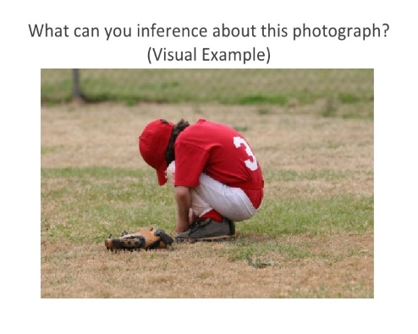 | Read the following article from Time for Kids (you may have to sign up for an account) and answer this question:  https://digital.emagazines.com/Time_for_Kids/20200327/index.html?t=aa8a20ac-4b32-4704-9e6d-12762c7a6554#p=4  Compare and Contrast (Matrix) the difference between comics and graphic novels. Tell me about the similarities and differences. | Today, I would like you to complete 3 reading passages on www.readtheory.org. Attached you will find your login and password for this site. | Convince the world to buy the ALL NEW and WILDLY DELICIOUS Pickle and Pinapple Frappuchino! You can create an advertisement, an audio commercial, a video commercial, or write a paragraph explaining why everyone should buy this new drink. Be creative! | There are many free audio book resources out there right now due to the Coronavirus Pandemic. Please choose a website where you can listen to an audio book. This book can be a picture book or chapter book. I have provided links for you to choose from for your book. Once you've listen to a book, resond to me by telling me what book you chose a little bit about the book.
Resources | Resources | Resources | Resources | Resources
 | https://digital.emagazines.com/Time_for_Kids/20200327/index.html?t=aa8a20ac-4b32-4704-9e6d-12762c7a6554#p=4 | www.readtheory.org |  | https://www.storylineonline.net/  https://stories.audible.com/start-listen

